ANALYTICS FOR HOSPITAL’S

HEALTH-CARE DATA

IDEATION PHASE

Data Flow Diagram

|  |  |
| --- | --- |
| Date | 09 October 2022 |
| Team ID | PNT2022TMID37727 |
| Project Name | Analytics for Hospitals’ Health-care data |
| Maximum Marks | 4 Marks |

EXAMPLE:

# FLOW

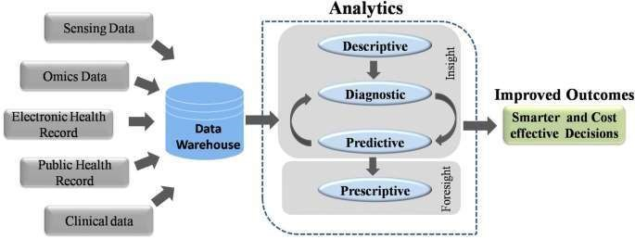

1.We can collect all the data we want, but it doesn’t do any good if we don’t know what to do with that information.

2.We need a centralized, systematic way of collecting, storing and analyzing data so we can use it to our advantage.

3.The collection of data in health care settings has become more streamlined in recent years. Not only does the data help improve day-to-day operations and better patient care, it can now be better used in predictive modeling. Instead of just looking at historical information or current information, we can use both datasets to track trends and make predictions. We are now able to take preventive measures and track the outcomes.

4.The fee-for-service style of health care is becoming a thing of the past. There is a growing demand for patient-centric, or value-based, medical care which has led to a considerable shift towards predictive and preventive measures in regards to public health in recent years. Data makes this possible.

5.Instead of simply treating the symptoms as they present, practitioners are able to identify patients at high risk of developing chronic illnesses and help to treat an issue before it surfaces.

6.This helps to lower costs for the practitioner, insurance company and patient as the preventive treatment may help to stave off long-term issues and expensive hospitalizations.

7.If hospitalization is necessary, data analytics can help practitioners predict risks of infection, deterioration and readmission. This too can help lower costs and improve patient care outcomes.